MINI PROJECT

#### (2021-22)

**“MEDITATION APP”**

PROJECT REPORT



INSTITUTE OF ENGINEERING & TECHNOLOGY

### SUBMITTED BY-

UTTAM SINGH (191500884)

UMANG SHARMA (191500872)

PRATEEK RAI (191500590)

UNDER THE SUPERVISON OF **DR. MANOJ VARSHNEY TECHNICAL TRAINER**

Department of Computer Engineering & Applications

Department of Computer Engineering and Applications GLA University, 17 km. Stone NH#2, Mathura-Delhi Road, Chaumuha, Mathura – 281406 U.P (India)

# Declaration

I/we hereby declare that the work which is being presented in the Bachelor of technology. Project “**Meditation Web Application”** in partial fulfillment of the requirements for the award of the Bachelor of Technology in Computer Science and Engineering and submitted to the Department of Computer Engineering and Applications of GLA University, Mathura, is an authentic record of my/our own work carried under the supervision of DR. MANOJ VARSHEY**, Technical Trainer, Dept. of CEA, GLA University.**

The contents of this project report, in full or in parts, have not been submitted to any other Institute or University for the award of any degree.

Department of Computer Engineering and Applications GLA University, 17 km. Stone NH#2, Mathura-Delhi Road, Chaumuha, Mathura – 281406 U.P (India)

**ACKNOWLEDGEMENT**

Presenting the ascribed project paper report in this very simple and official form, we would like to place my deep gratitude to GLA University for providing us the instructor DR. MANOJ VARSHNEY, our technical trainer and supervisor.

He has been helping us since Day 1 in this project. He provided us with the roadmap, the basic guidelines explaining on how to work on the project. He has been conducting regular meeting to check the progress of the project and providing us with the resources related to the project. Without his help, we wouldn’t have been able to complete this project.

And at last but not the least we would like to thank our dear parents for helping us to grab this opportunity to get trained and also my colleagues who helped me find resources during the training.

Thanking you

Sign: *UttamSingh* Sign: *PrateekRai*

Name of Candidate: Uttam Singh Name of Candidate: Prateek Rai University Roll Number: 191500884 University Roll No.: 191500590

Sign: *UmangSharma*

Name of Candidate: Umang Sharma University Roll Number: 191500872

# ABSTRACT

In this fast-growing world, everyone is busy in the race of coming first. No one has time to do any other stuff. This Busyness increases stress level in human and make human irritable. In this growing world with lots of technologies we make our life very easy by using lots of technical tools but slowly we lost our patience too. In this race of coming first we have no time to do proper exercise, yoga and meditation. So, to resolve this problem I made a Meditation Web Application where user can set timer and meditate for a time set on the timer.

## CONTENT

* Declaration 2
* Acknowledgement 3
* Abstract… 4
* Content… 5

1. CHAPTER -1 INTRODUCTION
   1. Context 7
   2. Motivation 7
   3. Objectives 8
   4. Existing System 8
   5. Sources 9
2. CHAPTER – 2 SOFTWAERE REQUIREMENTS
   1. Impact of Meditation 10
   2. Problem Statement 11
   3. Hardware and Software Requirements 12
3. CHAPTER – 3 TECHNOLOGY USED
   1. HTML 13
   2. CSS 14
   3. JavaScript 15
4. CHAPTER – 4 IMPLEMENTATION
   1. Features and functions 16
5. CHAPTER – 7

Conclusion 18

1. REFERENCES 19

**CHAPTER - 1**

**INTRODUCTION**

## CONTEXT

This Website “Success Connect” has been submitted in partial fulfilment of the requirements for the award of the degree of Bachelor of Technology in Computer Science and Engineering at GLA University, Mathura supervised by Dr. Manoj Varshney. This project has been completed approximately three months and has been executed in modules, meetings have been organized to check the progress of the work and for instructions and guidelines.

## MOTIVATION

I have been noticing since my childhood, initially there are very peace around us. Everyone had very descent nature and very helping nature too. But, now everyone is busy and rude in nature approximately. This is all because we lost our mental peace so I decided to make this web application.

## OBJECTIVE

In growing world of technologies, we need some time for ourselves to make us more productive. To increase productivity we need proper functioning of brain. For brain we need piece.

The main objective to made this web application is to provide a break to all users so that they can meditate and increase their productivity .

## EXISTING SYSTEM

This project is about meditation , there are many meditation app available on app store and web browser but we found few problems in that like a person can’t set the timer by themselves and he/she also can’t modify background as per their choice and we have put some changes in this meditation app which we will see in the feasibility of project given below. There are some application that are available are listed below.

1. **Best Overall:** [Calm](https://www.calm.com/)
2. **Best Budget:** [Insight Timer](https://insighttimer.com/)
3. **Best for Sleep:** [Headspace: Meditation & Sleep](https://headspace.pxf.io/c/2104074/1125973/13686?subid1=4767322&subid2=na0d5e0f75547418f8f6785fae10cfdaa10)
4. **Best for Beginners:** [Ten Percent Happier Meditation](https://www.tenpercent.com/)
5. **Best Guided:** [Buddhify](https://buddhify.com/)
6. **Best For Focus:** [Unplug](https://www.unplug.com/)
7. **Best Selection:** [Simple Habit](https://www.simplehabit.com/)

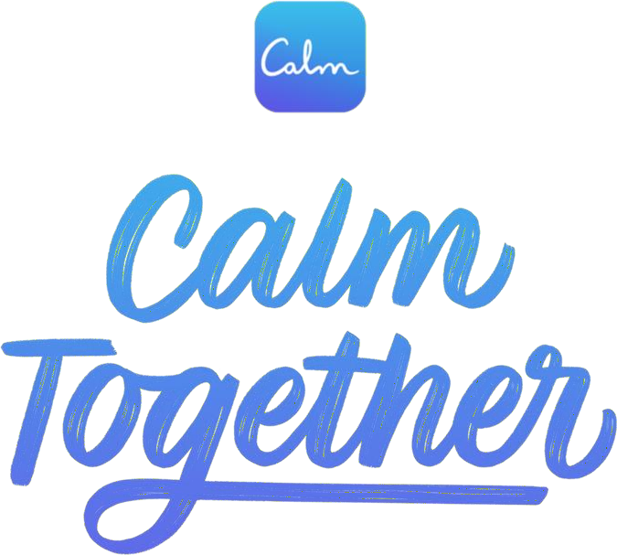

Figure - 1 Calm app poster

## SOURCES

The source of our project (including all the project work, documentations and presentations) will is available at the following link

[https://github.com/Uttamsingh11/MiniProject1_Meditation](GitHub)

# CHAPTER – 2 SOFTWARE REQUIREMENTS

## 2.1 IMPACT OF MEDITATION

Many people get succour from MEDITATION, as it’s a recovery technique that gives hope against anxiety and depression. For others, the only solution lies in taking antidepressants. In my case, my stress level was getting chronic with each passing day and I resorted to seeking help in the form of medication. But taking pills let me down completely! Getting to sleep by unnatural means was not conducive to mental healing, as the brain cannot detox. If anything, this forms an even unhealthier dependency as well as other complications. It was then that I started Heartfulness Meditation.

#### Meditate to Vent Anxiety

In simple terms, anxiety is when we can’t regulate our emotions, and anxiety-inducing thoughts have a way of bouncing around our mind

creating a major situation if we’re not aware of it. When we meditate, we assemble those thoughts, sit them down, observe them, talk to them and let them go. And with that, we release the pent-up tension. With regular meditation, I was able to rationalize over time that these thoughts are

illusory and they don’t define who I am.

MEDITATION PRACTICE also helps in knowing our bodies. We sense physical movements when we become more sensitive and aware. This is not easy; it takes time and regular practice. It’s during meditation that I realize I sit with my sensations in the same way that I sit with my thoughts. Little by little, this technique helped me out in dealing with anxious thoughts, so I could cut them before they crept in.

# 2.3 PROBLEM STATEMENT

Depression. What does it mean, and how does it transform a settled state of mind to a disturbed one? Depression is generally described as feeling miserable, isolated and with a lack of interest in activities that were once enjoyed with all enthusiasm. Mental stress is a major cause of depression. Endless brooding and worrying can result in anxiety, guilt, apathy and discontent. Moreover, it robs you of your sleep, further aggravating matters. In the daily hustle and bustle of today’s material world, finding peace for a brief moment can be a mammoth task. And when peace is lost, you open the door to negative emotions and a troubled state of mind.

## HARDWARE AND SOFTWARE REQUIREMENTS

### SOFTWARE REQUIREMENTS

|  |  |
| --- | --- |
| Technology Implemented | Front-End Technologies |
| Language Used | HTML, CSS, JavaScript |
| Development Environment | Visual Studio Code |
| Web Browser | Chrome / Firefox |

**Table -1 software requirrements**

### HARDWARE REQUIREMEN

|  |  |
| --- | --- |
| Processor | Intel core i5s/RYZEN 3 |
| Operating System | Windows 10 |
| RAM | 4+ GB |
| Hard Disk | 64 GB |
| Hardware Devices | Computer System |

Table -2 Hardware Requirements

## CHAPTER – 3 TECHNOLOGY USED

### 3.1 HTML

HTML stands for Hypertext Mark-up Language. It is used to design web pages using a mark-up language. HTML is the combination of Hypertext and Mark-up language. Hypertext defines the link between the web pages. A mark-up language is used to define the text document within tag which defines the structure of webpages.

HTML is a mark-up language that is used by the browser to manipulate text, images, and other content to display in the requiredformat.



Figure – 3 HTML

## 3.1 CSS

CSS (Cascading Style Sheets) is a stylesheet language used to design the webpage to make it attractive. The reason of using CSS is to simplify the process of making web pages presentable. CSS allows you to apply styles to web pages. More importantly, CSS enables you to do this independent of the HTML that makes up each webpage.

Styling has been an essential property for any website since many decades. It increases the standards and overall look of the website which makes it easier for the user to interact with it. A website cannot be made without CSS, as styling is MUST since no user would want to interact with a dull and shabby website.

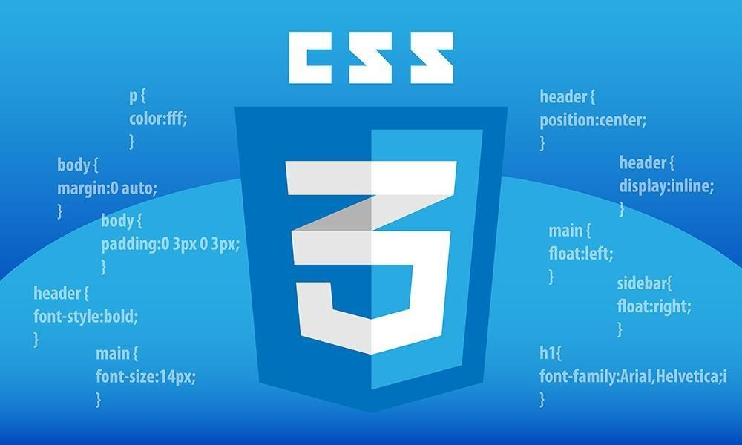

## JAVASCRIPT

JavaScript is the world most popular lightweight, interpreted compiled programming language. It is also known as scripting language for web pages. It is well-known for the development of web pages, many non-browser environments also use it. JavaScript can be used for Client-side developments as well as Server-

##### side developments.

JavaScript can be added to your HTML file in two ways:

* + - **Internal JS:** We can add JavaScript directly to our HTML file by writing the code inside the <script> tag. The <script> tag can either be placed inside the <head> or the <body> tag according to the requirement.
    - **External JS:** We can write JavaScript code in other file having an extension .js and then link this file inside the <head> tag of the HTML file in which we want to add this code.



**Figure – 5 Java Script**

# CHAPTER – 4 IMPLEMENTATION

## FEATURES AND FUNCTIONS

In this web application named as meditation app we have made few changes unlike of others meditation apps we have modified this app as we implemented music setup, background motion pictures and we also set the timer in the music player where user can easily set the timer of music by their own (for example – 2, 4 or 5min as per their need).

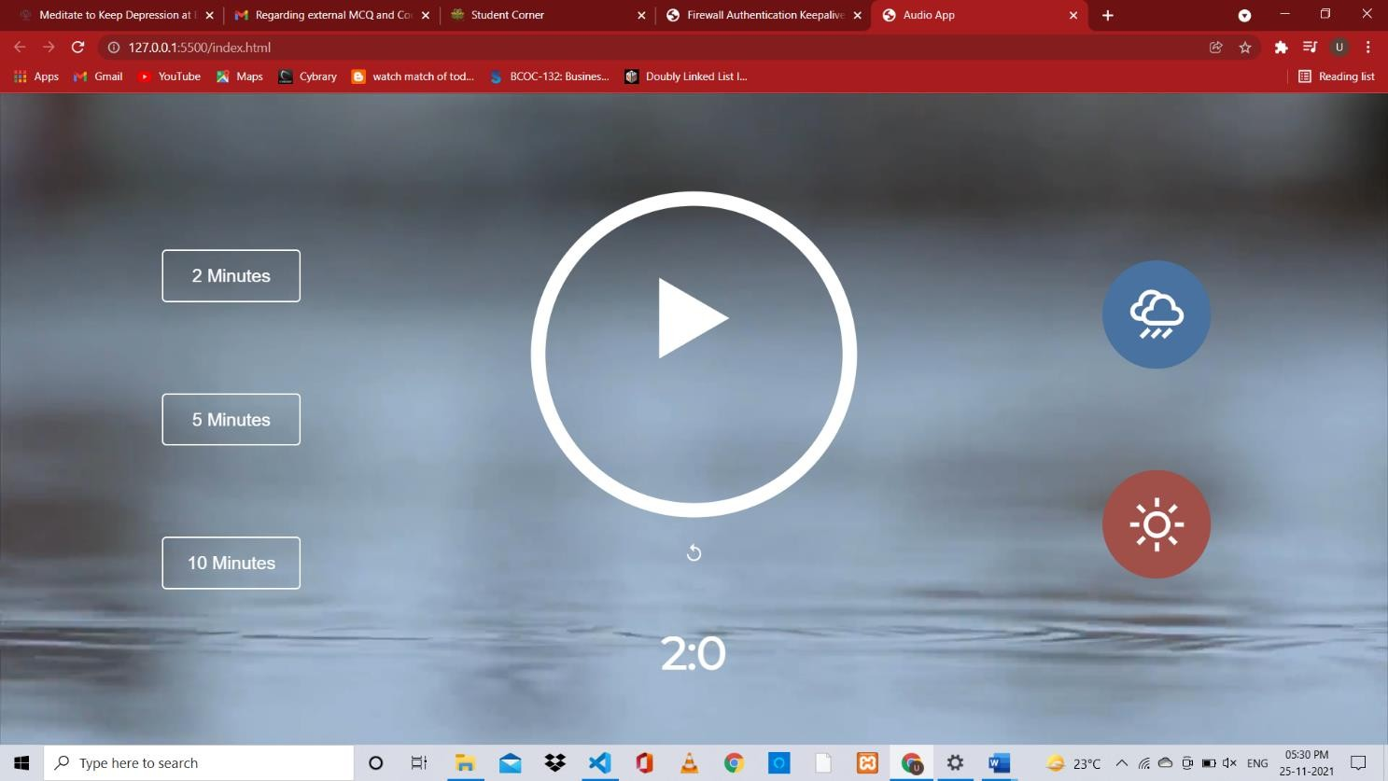

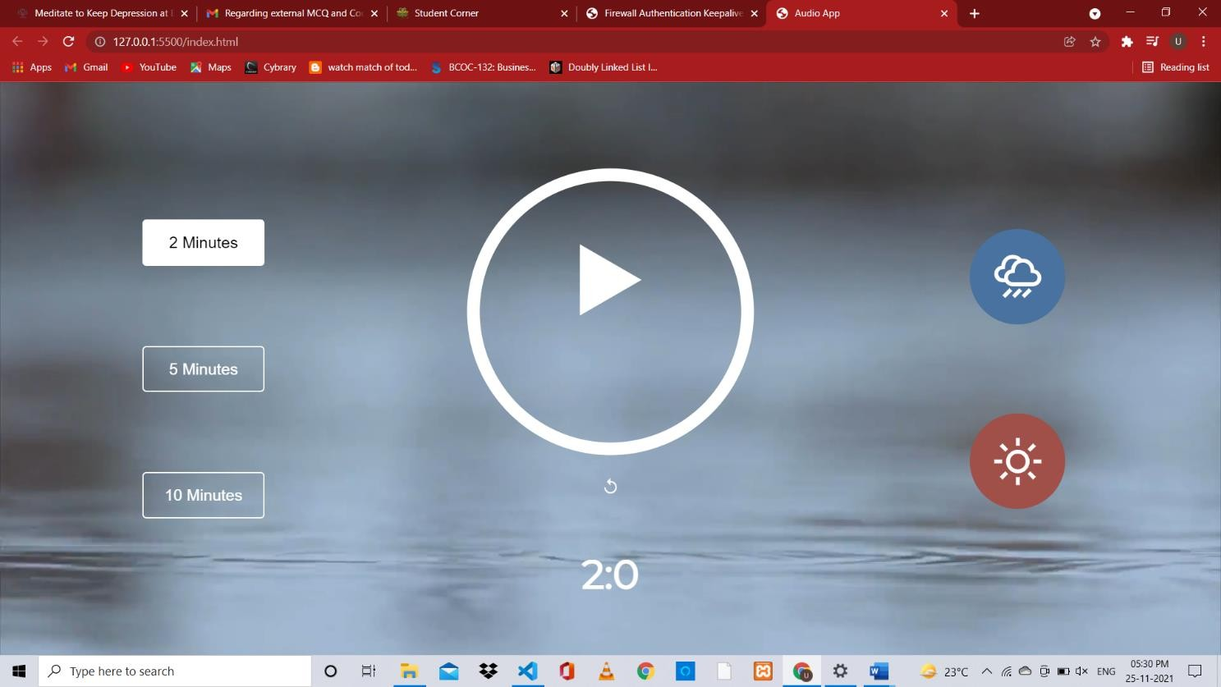

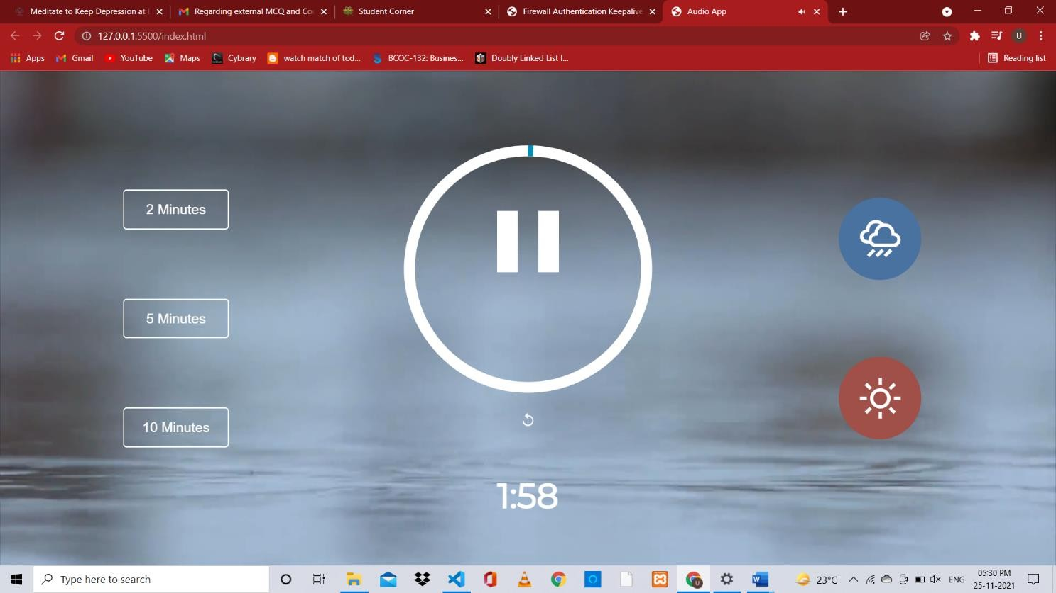

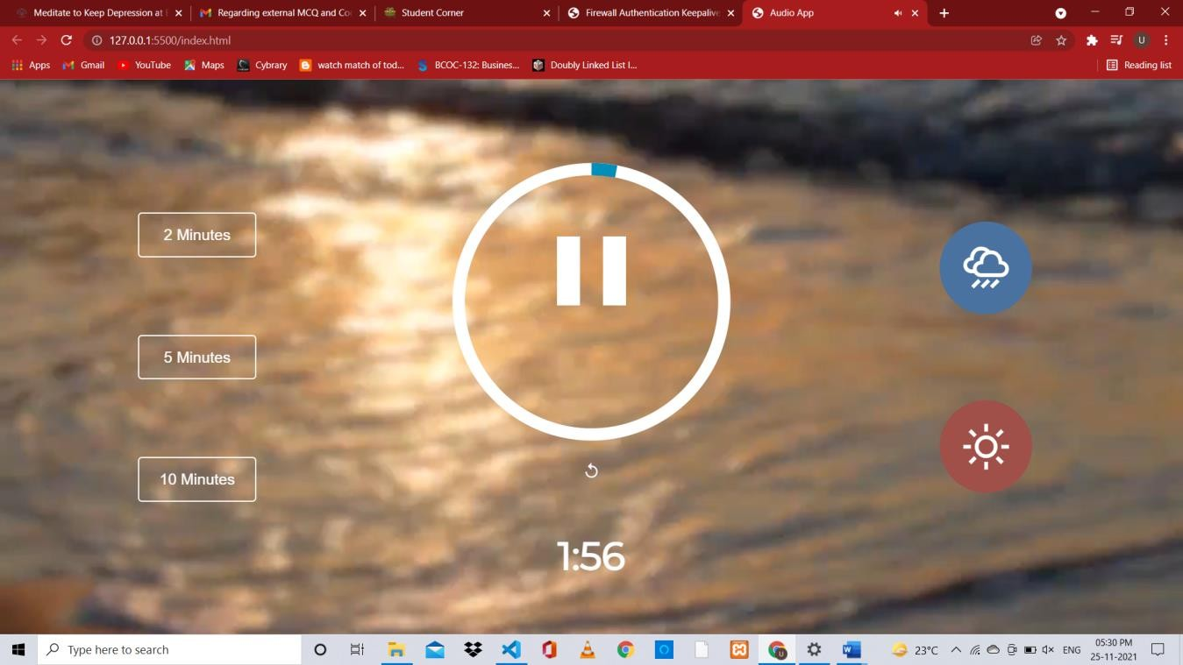

# CHAPTER - 5 CONCLUSION

By using **MEDITATION WEB APPLICATION,** we can resolve the problem of depression. Based on my research, I conclude that meditation has many scientifically proven benefits to both physical and mental health and well-being. There is also room for application of meditation practices in the modern health care system for treating a variety of different symptoms involved in physical and mental conditions. The findings regarding brain structural changes and Gray matter density should be further researched, as there are many applications for this knowledge in our health care system.

# REFERENCES

* + - [https://www.w3schools.com](https://www.w3schools.com/)
    - [https://www.geekforgeeks.com](https://www.geekforgeeks.com/)
    - Wikipedia